Project Documentation
Hotel Sales
1.Project Overview
Restaurant Sales Analysis using Power BI is a data visualization and business intelligence project designed to analyze restaurant sales performance and customer behavior. The project uses a restaurant sales dataset containing information such as transaction details, order type, menu items, categories, restaurant locations, customer ratings, quantity, and revenue.
2. Tools Used
- Microsoft Excel
- Power B
3. Dataset
- Source: 04 Restaurant Sales
- Data contains: Transaction ID, Order Date, Restaurant Location, Order Type, Menu Item, Category, Quantity, Unit Price, Order Total, Customer Rating.
4. Steps Followed
- Cleaned data in Excel (e.g., removed blanks, formatted columns)
- Used Excel formulas for basic analysis
- Imported cleaned data into Power BI
- Built dashboards using charts, slicers, and cards
5. Key Insights
-Top Menu Item: NY Strip Steak is the highest revenue generator (Over 3K), followed by BBQ Ribs and Grilled Salmon. This is the star product.
-Lowest Performers: Sparkling Water, Fresh Lemonade, Iced Coffee generate less than 200 revenue.
-Top Location: Downtown Manhattan generates highest revenue (3.6K+), followed by Coral Gables (3K+). Upper West Side is lowest (2K).

6. Screenshots
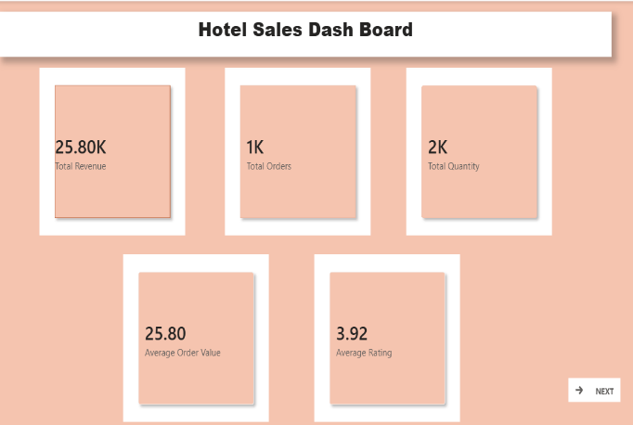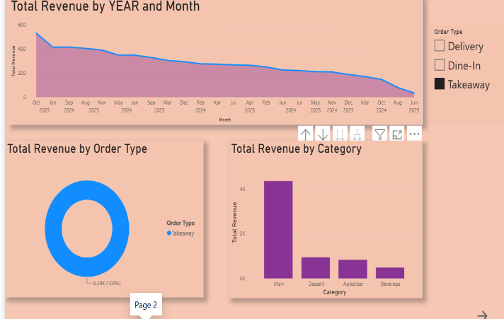
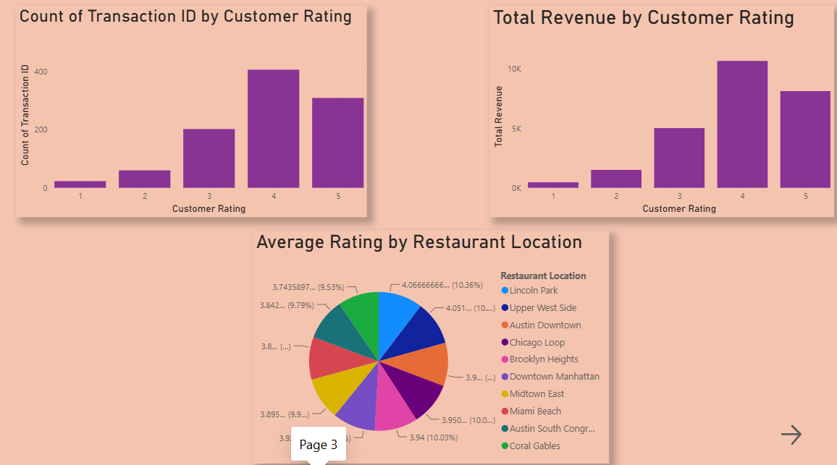
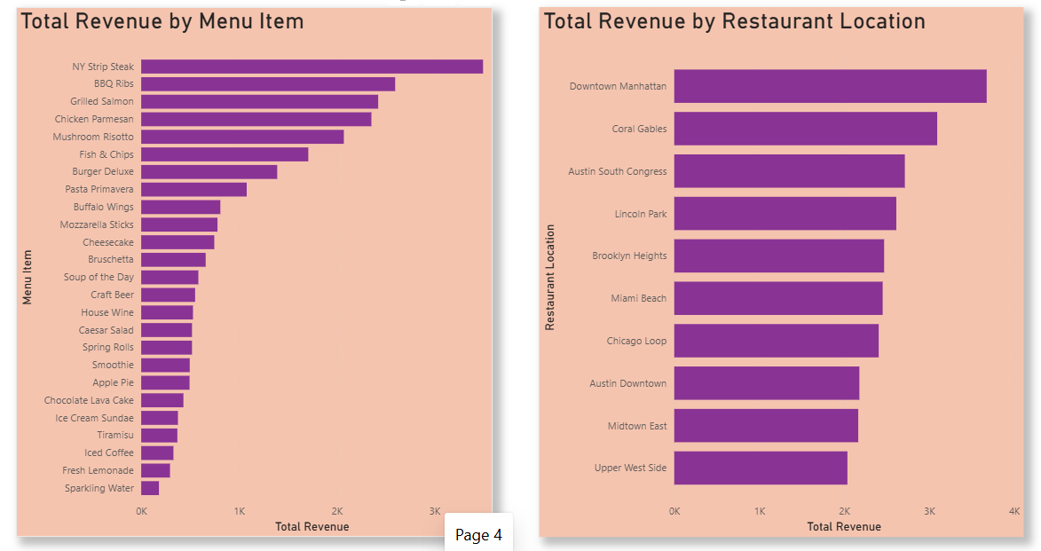
7. Files Included
- 04 Restaurant Sales-Cleaning.xlsx – Cleaned data and basic analysis
- MINI PROJECT.pbix – Power BI dashboard
- README.md – Project Discription
8. How to Use
- Open `sales_data.xlsx` to view the cleaned data. - Open `dashboard.pbix` in Power BI Desktop to explore the visuals.

